Experiment Name: Basic Shape Triangle, pentagon, trapezoid

Introduction: In this project I create some basic shape of triangle,pentagon and trapezoid.Lets make this word.

Code:

#include<windows.h>

#ifdef __APPLE__

#include <GLUT/glut.h>

#else

#include <GL/glut.h>

#endif

#include <stdlib.h>

#include <GL/gl.h>

#include <GL/glut.h>

void display(void)

{

/* clear all pixels */

glClear (GL_COLOR_BUFFER_BIT);

/* draw white polygon (rectangle) with corners at

* (0.25, 0.25, 0.0) and (0.75, 0.75, 0.0)

*/

glColor3f (1.0, 1.0, 1.0);

glBegin(GL_QUADS); //Begin quadrilateral coordinates

//Trapezoid

glVertex3f(0.05f, 0.05f, 0.0f);

glVertex3f(0.35f, 0.05f, 0.0f);

glVertex3f(0.40f, 0.35f, 0.0f);

glVertex3f(0.00f, 0.35f, 0.0f);

glEnd(); //End quadrilateral coordinates

glBegin(GL_TRIANGLES); //Begin triangle coordinates

//Pentagon

glVertex3f(0.5f, 0.05f, 0.0f);

glVertex3f(0.75f, 0.05f, 0.0f);

glVertex3f(0.5f, 0.35f, 0.0f);

glVertex3f(0.5f, 0.35f, 0.0f);

glVertex3f(0.75f, 0.05f, 0.0f);

glVertex3f(0.75f, 0.35f, 0.0f);

glVertex3f(0.5f, 0.35f, 0.0f);

glVertex3f(0.75f, 0.35f, 0.0f);

glVertex3f(0.63f, 0.50f, 0.0f);

//Triangle

glVertex3f(0.30f, 0.65f, 0.0f);

glVertex3f(0.60f, 0.65f, 0.0f);

glVertex3f(0.45, 0.85f, 0.0f);

glEnd();//End triangle coordinates

/* don't wait!

* start processing buffered OpenGL routines

*/

glFlush ();

}

void init (void)

{

/* select clearing (background) color */

glClearColor (0.0, 0.0, 0.0, 0.0);

/* initialize viewing values */

glMatrixMode(GL_PROJECTION);

glLoadIdentity();

glOrtho(0.0, 1.0, 0.0, 1.0, -10.0, 10.0);

}

int main(int argc, char** argv)

{

glutInit(&argc, argv);

glutInitDisplayMode (GLUT_SINGLE | GLUT_RGB);

glutInitWindowSize (600, 600);

glutInitWindowPosition (100, 100);

glutCreateWindow ("hello");

init ();

glutDisplayFunc(display);

glutMainLoop();

return 0; /* ISO C requires main to return int. */

}

Output:

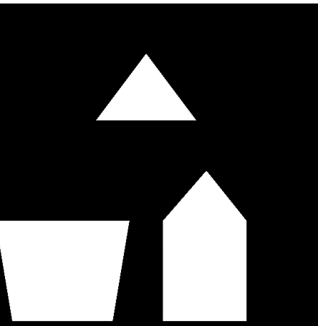

Conculaton:This shape are make some function.First of all start glutInit(&argc, argv); for display glutInitDisplayMode (GLUT_SINGLE | GLUT_RGB); for window glutInitWindowSize (600, 600);glutInitWindowPosition (100, 100);glutCreateWindow ("hello");and we need vertexand to see window need colour function.